Enrolling Incapacitated Adults in Health and Medical Research: Standardised Wording for use at WA public health system sites

Instructions for researchers:
This document provides standard wording that can be used when enrolling research candidates at WA public health system sites under Part 9E of the Guardianship and Administration Act 1990 (Act). This document assumes that researchers have prior knowledge of Part 9E of the Act and familiarity with the Department of Health’s GAA Medical Research Guidance Document. This document is provided as guidance only and is not mandatory.
Researchers may use some or all of the standard wording in relevant site-specific documents. Changes may be requested by Human Research Ethics Committees (HRECs) and/or sites on a case-by-case basis to ensure that any wording is appropriate for the specific research project being reviewed. This document includes:
1. General Information – this information is designed to be provided to Research Decision Makers (RDMs) and Research Candidates to familiarise themselves with the Act before making any decisions. This section includes example wording for information on key terms, the two enrolment pathways under the Act and Frequently Asked Questions.
2. Additional Information to be included in Patient Information and Consent Forms – different information is provided for each enrolment pathway and audience type (i.e. RDM or Research Candidate). This information assumes that the General Information has been provided to and understood by RDMs and Research Candidates.
3. Information to be included in Research Protocol for HREC review
Researchers should familiarise themselves with the GAA Medical Research Guidance Document and other relevant documentation on the Research Governance Service Document Templates page prior to submitting their ethics and governance applications.
For assistance with applying the Act and adapting the standard wording to your specific project, please contact your relevant WA Health research ethics and/or governance office. For general policy advice regarding the Act, please contact the Department of Health Research and Innovation Office.
Quick navigation:
For Studies with Medical Research with Consent of a Research Decision Maker
General Information
Research Decision Maker PICF
Research Candidate PICF
Research Protocol
For Studies with Urgent Medical Research without Consent
General Information
Research Decision Maker PICF
Research Candidate PICF
Research Protocol
General Information to be provided to Research Decision Maker and/or Research Candidate

GENERAL INFORMATION: ENROLLING ADULTS WHO DO NOT HAVE THE CAPACITY TO CONSENT TO THEIR PARTICIPATION IN HEALTH AND MEDICAL RESEARCH IN WESTERN AUSTRALIA
In Western Australia, the Guardianship and Administration Act 1990 recognises that there may be occasions when adults who do not have the capacity to consent to their participation in health or medical research may require someone to make decisions on their behalf.
The Guardianship and Administration Act 1990 allows researchers to enrol incapacitated adults into health or medical research via two potential pathways:
- Medical Research with Consent of a Research Decision Maker
- Urgent Medical Research without Consent
To help you understand the two pathways better, there are a few key terms that you should first familiarise yourself with.
Medical Research | Within the scope of the Guardianship and Administration Act 1990, this term includes research that is conducted with or about individuals, or their data or tissue, in the field of medicine or health.
Research Candidate | This is the person whose participation in the research project described in this information form is being sought.
Research Decision Maker (RDM) | This is a person who may consent or refuse to provide consent on behalf of a Research Candidate for the Research Candidate’s participation in health or medical research.  Under the Guardianship and Administration Act 1990 (Act), a Research Decision Maker may be a guardian appointed under the Act, spouse, de facto partner, relative or those with a close personal relationship depending on the circumstances.  A person can only be a Research Decision Maker if the Research Candidate is unable to make reasonable judgements about their own participation in the research.  More information about the Research Decision Maker is provided further down in this document.
Independent Medical Practitioner (IMP) | This person’s role is to form an independent determination regarding the Research Candidate’s participation in the research.  The Independent Medical Practitioner must be a medical practitioner who is registered under Western Australian law in the medical profession (other than a student). They must also meet the requirements for independence under the Guardianship and Administration Act 1990 to avoid conflicts of interest regarding whether the Research Candidate is enrolled in the research or not.
Research Decision | A Research Decision means a decision to consent or refuse to consent to the Research Candidate’s participation in the research.

Pathway 1: Medical Research with Consent of a Research Decision Maker
The Research Decision Maker has the authority to make a Research Decision. That means that the Research Decision Maker can either consent or refuse to consent to the Research Candidate’s participation in the research. Under the Guardianship and Administration Act 1990, a person can make this Research Decision as a Research Decision Maker if:
- They have authority as a Research Decision Maker (see Figure 1).
- They feel comfortable making a Research Decision on behalf of the Research Candidate.
- They have received the Independent Medical Practitioner’s determination in writing (if practicable before the medical research commences) with regards to the below points and having considered their determination, they believe that:
  - Participating in the research would be in the Research Candidate’s best interests, or not adverse to the Research Candidate’s best interests.
  - There are no substantial risks associated with participating in the research beyond the risks of the Research Candidate’s normal care.
A Research Decision Maker cannot consent to the Research Candidate’s participation in the Medical Research if the participation is inconsistent with any advance health directive in operation in respect of the Research Candidate.
If it is not practicable to receive the Independent Medical Practitioner’s determining in writing before the research commences, the determination may be provided orally before the Medical Research commences, but must be provided to the Research Decision Maker in writing after the Research Candidate commences participation in the Medical Research.

Pathway 2: Urgent Medical Research without Consent
In an emergency, a health practitioner is able to administer urgent treatment to a person as part of a medical research procedure without consent, if the researcher believes on reasonable grounds that the treatment is urgently needed to:
- save the person's life; or
- prevent serious damage to the person's health; or
- prevent the person from suffering or continuing to suffer significant pain or distress.
The researcher can only do this if it is impracticable to contact a Research Decision Maker in a timely manner, there is no advanced care directive that prohibits that treatment, and the researcher has received a determination from an Independent Medical Practitioner that the research is in the Research Candidate’s best interests, or not adverse to their interests, and that there are no substantial risks associated with participating in the research beyond the risks of the Research Candidate’s normal care.

Frequently Asked Questions
Who can be a Research Decision Maker?
Figure 1 - Hierarchy of Research Decision Makers
A flowchart has been provided by the Office of the Public Advocate as guidance regarding the hierarchy of Research Decision Makers under the Guardianship and Administration Act 1990.
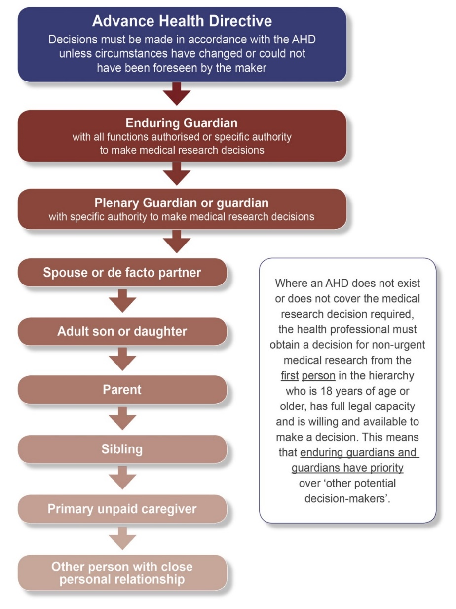

Further information about Figure 1 can be obtained from the Office of the Public Advocate.
Office of the Public Advocate
PO Box 6293, EAST PERTH WA 6892
Telephone: 1300 858 455
Email: opa@justice.wa.gov.au
Web: www.publicadvocate.wa.gov.au

How are best interests and risks considered?
The below factors must be taken into account by the Independent Medical Practitioner (IMP) when making their determination regarding the Research Candidate’s participation in the research.

Research Decision Makers should be aware of this information and consider it in light of the IMP’s determination when making a Research Decision in respect of the Research Candidate.

Best interests

The IMP must determine that participation in this research is in the best interests of the Research Candidate or will not be adverse to the interests of the research candidate.
The IMP must take into account:
- the wishes of the person (to the extent they can be ascertained) as the paramount consideration;
- the likely effects of research participation, including:
  - the existence, likelihood and severity of any potential risks;
  - whether those risks are justified by any likely benefits of the research to the candidate or to the broader community;
- any consequences for the Research Candidate if they are not involved in the research; and
- any alternative treatments available to the Research Candidate.

Risks associated with participating in the research

The IMP must determine that the Research Candidate’s participation in the research will be in accordance with one of following risk categories:
- will only involve observing the candidate or carrying out another non-invasive examination, treatment or procedure; or
- if (i) does not apply - will not involve any known substantial risks to the candidate; or
- if (i) and (ii) do not apply and there is an existing treatment available to the candidate - will not involve any known substantial risks to the candidate greater than the risks associated with that treatment; or
- if (i), (ii) and (iii) do not apply - will not involve substantial risks to the candidate greater than if the candidate did not participate in the research.

The IMP must take into account:
- whether the Research Candidate’s participation in the research will involve any known substantial risks to the candidate;
- whether there is an existing treatment available to the Research Candidate;
- if there is an existing treatment available to the Research Candidate –
  - whether there are substantial risks to the candidate involved in the existing treatment available to the candidate;
  - if there are substantial risks involved in the existing treatment – whether those risks are greater than the risks involved in participating in the research;
- if there is no existing treatment available – whether the risks involved in participating in the research are greater than not participating in the research.
If a Research Decision Maker consents to a Research Candidate’s participation in health or medical research, can they later change their decision?
Yes, a Research Decision Maker can decide that the Research Candidate will no longer participate in the research, even if the original Research Decision was to consent to their participation.
What if the Research Candidate regains capacity?
If the Research Candidate regains capacity while they are participating in the research, the researchers will:
- Discontinue the Research Candidate’s participation as soon as it is safely practicable. Their participation will not be discontinued if it is not safe to do so.
- Approach the Research Candidate to obtain their consent to recommence/continue participating in the study.
This applies to both the ‘Medical Research with Consent of a Research Decision Maker’ and ‘Urgent Medical Research without Consent’ pathway under the Guardianship and Administration Act 1990.
What if the Research Candidate is enrolled without consent into urgent medical research, and a Research Decision Maker then becomes available?
If a Research Candidate is enrolled into the ‘Urgent Medical Research without Consent’ pathway, the researchers will continue to take reasonable steps to contact a Research Decision Maker to obtain consent.
If a Research Decision Maker becomes available, the researchers must obtain consent from the Research Decision Maker in order to continue the Research Candidate’s participation in the health or medical research, as per the ‘Medical Research with Consent of a Research Decision Maker’ pathway.

Additional Information to be included in Patient Information and Consent Forms, after General Information has been provided

Pathway 1: Medical Research with Consent of a Research Decision Maker

Research Decision Maker | We are asking you to review this Patient Information and Consent Form because you have been identified as a potential Research Decision Maker for the Research Candidate. You are being asked to provide consent on behalf of the Research Candidate under the ‘Medical Research with Consent of a Research Decision Maker’ pathway of the Guardianship and Administration Act 1990.  Please advise the researchers immediately if you are aware that the Research Candidate has an advance health directive in operation, including if you are unsure whether participation in the research is inconsistent with the advance health directive.
Research Candidate | You have been enrolled in this research project in accordance with the Guardianship and Administration Act 1990.  As you were not able to consent to participate in the study at the time of the treatment, the study team approached a Research Decision Maker (e.g. next-of-kin) for consent on your behalf.  Now that you have regained capacity, we are seeking your consent to continue to participate in the study.  You were enrolled under the ‘Medical Research with Consent of a Research Decision Maker’ pathway of the Guardianship and Administration Act 1990.

Pathway 2: Urgent Medical Research without Consent

Research Decision Maker | The Research Candidate has been enrolled in this research project under the ‘Urgent Medical Research without Consent’ pathway of the Guardianship and Administration Act 1990.  Now that we have been able to contact you, we are asking you to review this Patient Information and Consent Form because you have been identified as a potential Research Decision Maker for the Research Candidate. From this point on, the ‘Medical Research with Consent of a Research Decision Maker’ pathway of the Guardianship and Administration Act 1990 applies.  Please advise the researchers immediately if you are aware that the Research Candidate has an advance health directive in operation, including if you are unsure whether participation in the research is inconsistent with the advance health directive.
Research Candidate | You have been enrolled in this research project in accordance with the Guardianship and Administration Act 1990.  You were enrolled without obtaining your consent in advance because it was believed that you required urgent treatment and it was impracticable to contact a Research Decision Maker (e.g. next-of-kin) in a timely manner to provide consent on your behalf.  Now that you have regained capacity, we are seeking your consent to continue to participate in the study.  You were enrolled under the “Urgent Medical Research without Consent’ pathway of the Guardianship and Administration Act 1990.

Information to be included in Research Protocol for HREC review

Pathway 1: Medical Research with Consent of a Research Decision Maker

This project seeks to recruit incapacitated Research Candidates who are unable to consent on their own behalf. This study will ensure that any process used to recruit these participants complies with this protocol, the requirements of the National Statement, and meets all relevant legal and institutional obligations for enrolling incapacitated Research Candidates unable to consent.
Specifically, this study will adhere to the requirements of the Guardianship and Administration Amendment (Medical Research) Act 2020 and follow the relevant institutional requirements including the need to obtain a determination from an Independent Medical Practitioner for each Research Candidate, prior to enrolment and to meet all reporting obligations.
This project will enrol Research Candidates under the “Medical Research with consent of Research Decision Maker” pathway only. It will not enrol Research Candidates under “Urgent Medical Research without consent”.

As per s110ZR(c) of the Act, the ‘timeframe’ within which a Research Candidate must be enrolled in the research for the validity of the research to be maintained is defined as (insert description of ‘timeframe’ here).

Pathway 2: Urgent Medical Research without Consent

This project seeks to recruit incapacitated Research Candidates unable to consent on their own behalf. This study will ensure that any process used to recruit these participants complies with this protocol, the requirements of the National Statement, and meets all relevant legal and institutional obligations for enrolling incapacitated Research Candidates unable to consent.
Specifically, this study will adhere to the requirements of the Guardianship and Administration Amendment (Medical Research) Act 2020 and follow the relevant institutional requirements including the need to obtain a determination from an Independent Medical Practitioner for each Research Candidate, prior to enrolment and to meet all reporting obligations.
Approval is being sought to enrol Research Candidates under the “Urgent Medical Research without consent” pathway. Research Candidates will only be enrolled in this pathway if they require urgent treatment and it is not practicable to obtain a Research Decision from a Research Decision Maker via the “Medical Research with consent of Research Decision Maker” pathway.

As per s110ZS(f) and s110ZS(g) of the Act, the ‘timeframe’ within which a Research Candidate must be enrolled in the research for the validity of the research to be maintained is defined as (insert description of ‘timeframe’ here).¹

The ‘timeframe’ may not necessarily be defined in minutes/hours/days but may be an event occurring, or milestone being reached.

